TSA Lumenier Drone Competition

Overview
As part of your city’s Emergency Services Response Unit, you are responsible for responding to emergency situations and using your UAS as required. This competition will test your preparation in designing and building a UAS that has advanced features, as well as your piloting capabilities.

Course Challenge
This single course has two segments to it that are timed individually. First section is to find and hook the ‘’hazardous material’’ and dispose of it in a marked zone. Students will have 120 seconds to dispose of the hazardous material. Once the object is dropped in the basket the timer should be reset to initiate the second section, now with 90 seconds on the clock they must pick up the stranded puppy and deliver it to safety! Each Student or team will start with 100 points. However, points will be deducted for various reasons listed on a separate key.

Course Size
The course size is 32’ x 16’ x 12’, this can be accomplished by taking two canopy tents and fastening them together and extending the legs (if needed). Bird or batting cage style netting will be hung around all sides to protect spectators during the event. At no time should a person be in the net while the UAS is armed.
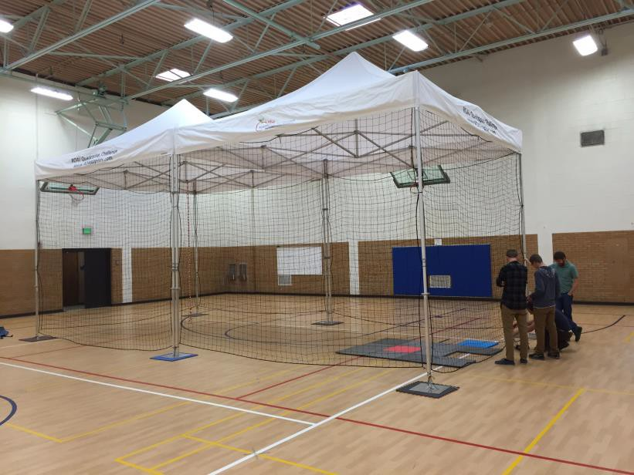

Course Layout

The objective for this course is to challenge your piloting skills, as well as the drone you built and its capabilities. The pilot must take off from 2’x2’ platform, proceed towards the front of the course, around the obstacle (A) pick up Object A. Once the item is acquired, student must head towards the back of the course carefully going above the second obstacle (B). Once they are over the basket (C) in the rear right corner of the course, hover with the hazardous material over the opening and release the hook, dropping the ball into the basket. Next, fly around obstacle (D) and pick up Object B, quickly take Object B to the safe zone by flying underneath obstacle (E) on the right side of the course. Pick your path around obstacle (F), line up for the drop and release the object into the safe zone. Finally, land your UAS back on the takeoff pad.

Objects
Object A. (Hazardous Material) – ferrous metal container, max. weight .5 lbs.
Object B. (Stuff Dog with Collar and Metal Tag – max wt .5 lbs. | Placed in left rear corner 12” away from each net.

Obstacle Measurements
These measurements will be for the accurate placement of each obstacle*
Obstacle A. (Silhouette) - 10”Wx10” Lx48”H | 8ft from front, 5ft from left side towards center.
Obstacle B. Over obstacle - 5ft L x 2ft W | Between left side and drone take off. (Folding table)
Obstacle C. Container – 2ftx 2ft (At least 24” deep) | Placed in rear right corner 6” away from net siding.
Obstacle D. Back wall – 12"Wx 60” Lx 48”H | Centered on the back wall of the course extruding towards the front.
Obstacle E. Under obstacle – 5ft L x 2ft W | Between drone take off and right side. (folding table)
Obstacle F. (silhouette) 10” Wx 10” Lx 48”H | 10ft from front of course, 5ft from right side towards center.

